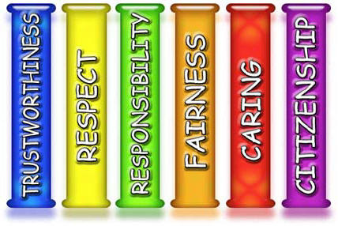

**Counselor’s Corner**

**Pearl Lower Elementary – Aug/Sept 2020**

**Amanda Bagwell, School Counselor**

**This year your child will be learning about Character Traits.**

**These traits include: Caring, Citizenship, Fairness, Respect, Responsibility, and Trustworthiness.**

**I will see your child’s class at least twice each month. They will be learning how to have good character at school and at home.**

**I am looking forward to a GREAT year!**

[](http://www.google.com/url?sa=i&rct=j&q=character+education+clipart&source=images&cd=&cad=rja&docid=ZGb6Q4YnAfoY-M&tbnid=7ZAjVXu5luIinM:&ved=0CAUQjRw&url=http://www.worthington.k12.oh.us/domain/265&ei=7VxTUZzACKTU2AWD0ICoAQ&psig=AFQjCNERQtKs5KPGLi--Sw3C5DN1ZBGCsQ&ust=1364503515759684)

Citizenship

Do your share to make your school and community better • Cooperate • Get involved in community affairs • Stay informed; vote • Be a good neighbor • Obey laws and rules • Respect authority • Protect the environment • Volunteer

Fairness

Play by the rules • Take turns and share • Be open-minded; listen to others • Don’t take advantage of others • Don’t blame others carelessly • Treat all people fairly

Trustworthiness

Be honest • Don’t deceive, cheat, or steal • Be reliable — do what you say you’ll do • Have the courage to do the right thing • Build a good reputation • Be loyal — stand by your family, friends, and country

Responsibility

Do what you are supposed to do • Plan ahead • Persevere: keep on trying! • Always do your best • Use self-control • Be self-disciplined • Think before you act — consider the consequences • Be accountable for your words, actions, and attitudes • Set a good example for others

Respect

Treat others with respect; follow the Golden Rule • Be tolerant and accepting of differences • Use good manners, not bad language • Be considerate of the feelings of others • Don’t threaten, hit or hurt anyone • Deal peacefully with anger, insults, and disagreements

Caring

Be kind • Be compassionate and show you care • Express gratitude • Forgive others • Help people in need