Adult Counseling Resources

Disclaimer: These are locally licensed counseling centers in our area. This is not an endorsement for any particular counseling agency. I always recommend that you find a counselor with a counseling style that makes you comfortable rather than take the opinion of someone else.

Cornerstone Counseling
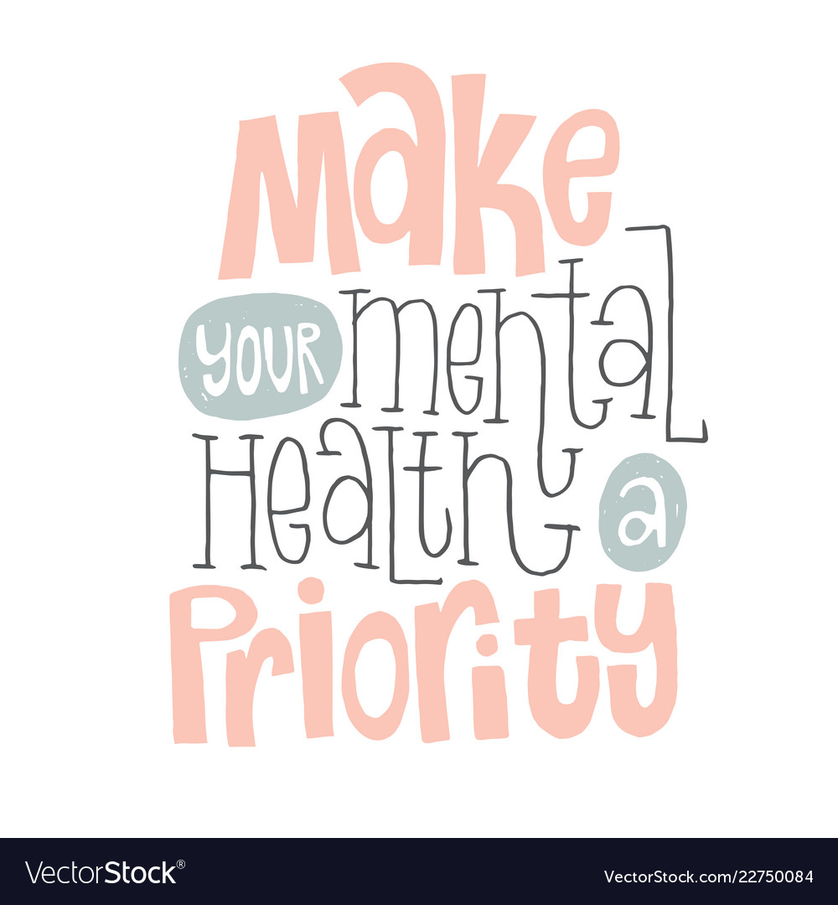
Jackson
4500 I-55 North, Suite 279 (Highland Village)
Jackson, MS 39211
601-405-7440
http://www.cornerstone.ms/

Count it all Joy Counseling
Jackson
4500 I-55 North Suite 220
Jackson, MS 39211
601-460-4569
www.countjoy.net

Crossroads Counseling
Pearl/Brandon
5611 Highway 80 East
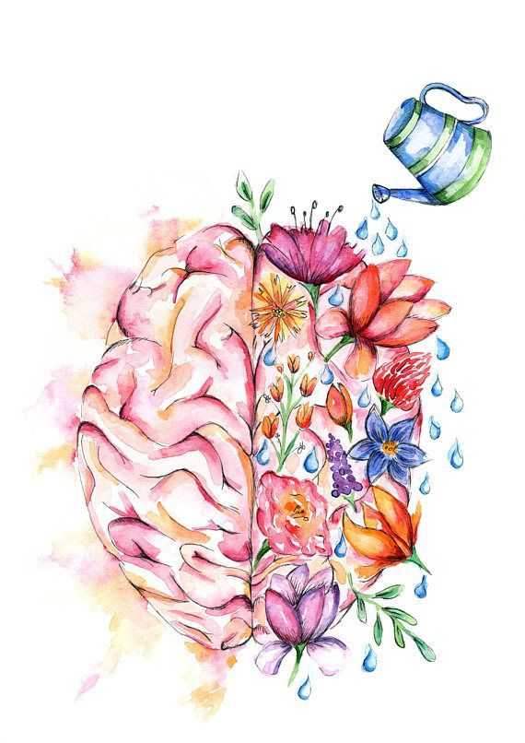
Pearl, MS 39208
601-939-6634
https://www.crossroadscounselingms.com/

Turning Point Counseling
Flowood
117 Park Circle Drive
Flowood, MS 39232
601-850-7047
www.turningpointms.com

Region 8 - Rankin County
Brandon
613 Marquette Road
Brandon, MS 39043
601-825-8800
http://region8mhs.org/

Watershed
Jackson
1635 Lelia Dr
Jackson, MS 39216
601-362-7020
https://www.watershedcounselingms.com/

